PREDICTIVE ANALYTICS PROJECT REPORT

CONTENTS OF THE REPORT
- Cover page
- Certificate
- Declaration
- Acknowledgement
- Table of Content

  - Introduction
Overview of Predictive Analytics
Importance of prediction in the selected domain Problem Statement
Objectives of the study Scope of the project Expected outcomes
  - Source of dataset
Name of dataset
Source link (Kaggle / UCI / Government portal / Primary source) Description of attributes
Number of rows, columns Type of prediction:
  - Dataset Preprocessing
  - Analysis on dataset (for each objective) General Description
Specific Requirements Analysis results Visualization
  - Model Development
Minimum three predictive models must be trained.
  - Model Comparison
  - Best Model Identification
  - Conclusion
  - Future scope

PREDICTIVE ANALYTICS PROJECT REPORT
(Project Semester August-December 2025)

Predictive Analysis of Customer Shopping Behavior Analysis using Regression and Classification Models

Submitted by

Shanmuka Satya Deva Reddy Karri

Registration No: 12308243

Programme and Section: Computer Science and Engineering, K23BR Course Code INT234

Under the Guidance of Mr. Vikas Mangotra 31488
(Name of faculty coordinator with UID and designation)

Discipline of CSE/IT Lovely School of Computer Science
Lovely Professional University, Phagwara

CERTIFICATE

This is to certify that Shanmuka Satya Deva Reddy Karri bearing Registration no. 12308243 has completed INT234 project titled, “Predictive Analysis of Customer Shopping Analysis using Regression and classification Models” under my guidance and supervision. To the best of my knowledge, the present work is the result of his/her original development,
effort and study.

Signature and Name of the Supervisor Designation of the Supervisor
School of …………………………………………….
Lovely Professional University Phagwara, Punjab.

Date:

DECLARATION

I, Shanmuka Satya Deva Reddy Karri, student of Computer Science and Engineering under CSE/IT Discipline at, Lovely Professional University, Punjab, hereby declare that all the information furnished in this project report is based on my own intensive work and is genuine.

Date: 14/12/2025 Signature

Registration No. 12308243 K.S.S.Deva.Reddy

Introduction

Overview of Predictive Analytics
Predictive analytics uses historical data, statistical techniques, and machine learning algorithms to identify patterns and predict future outcomes. With Python libraries such as Pandas, NumPy, Matplotlib, Seaborn, and Scikit-learn, predictive models can be built to analyze customer behavior and support data-driven decision-making

Importance of Prediction in the Selected Domain
In the retail and e-commerce domain, understanding customer purchasing behavior is crucial for improving sales strategies, personalization, inventory planning, and customer retention. Predicting purchase amounts and classifying customers based on spending levels helps businesses optimize marketing efforts and enhance customer experience

Problem Statement
Retail datasets contain large volumes of customer and transaction data, making manual analysis inefficient and error-prone. There is a need for an automated predictive system that can analyze shopping behavior and accurately predict purchase amounts while also classifying customers into high-value and low-value segments.

Objectives of the Study
The primary objectives of this project are:
    - To analyze customer shopping behavior using exploratory data analysis
    - To preprocess and encode categorical attributes
    - To build regression models to predict purchase amount
    - To classify customers into high and low purchase categories
    - To compare multiple machine learning models and identify the best performer

1.5 Scope of the Project
The project focuses on structured shopping behavior data and applies classical machine learning algorithms. External factors such as customer income, location economics, or real-time data streams are not considered.

1.6 Expected Outcomes
The expected outcomes of this project include:
    - Identification of factors influencing customer purchase amount
    - Accurate prediction of purchase value using regression models
    - Effective classification of customers into spending categories
    - Comparative performance analysis of multiple models

Source of Dataset

Name of Dataset
Shopping Behavior Dataset

Source Link
Kaggle
Link: https://www.kaggle.com/datasets/zubairdhuddi/shopping-dataset
Github Link:
https://github.com/Satya4196/Customer-Shopping-behavior-Analysis-using-Regression-and-classification-models
LinkedIn Link:
https://www.linkedin.com/feed/update/urn:li:activity:7405939203903098880/

Description of Attributes
The dataset consists of customer demographic details and purchase-related information used for predictive analysis. The attributes used in this project are described below:

Attribute Name | Description
Purchase Amount (USD) | Target variable representing the total amount spent by the customer during a transaction.
Gender | Categorical variable indicating the gender of the customer.
Item Purchased | Categorical variable representing the specific product purchased by the customer.
Category | Categorical variable indicating the product category of the purchased item.
Location | Categorical variable representing the geographical location of the customer.
Size | Categorical variable indicating the size of the purchased item.
Frequency of Purchases | Categorical variable indicating how frequently the customer makes purchases.

Number of Rows and Columns
    - Number of Rows: Based on dataset records after preprocessing
    - Number of Columns Used: 6 Based on dataset records after preprocessing
      - 5 input (independent) variables
      - 1 target (dependent) variable
(Note: The original dataset contains additional columns which were excluded to maintain model simplicity and relevance.)

Type of Prediction
This project performs two types of prediction:
- Regression Prediction
- Predicts the exact purchase amount (USD) spent by a customer using:
Linear Regression
K-Nearest Neighbours (KNN) Regression
Decision Tree Regressor

2. Binary Classification Prediction
Classifies customer purchases as High Purchase or Low Purchase relative to the dataset median using:
K-Nearest Neighbors (KNN) Classifier
Decision Tree Classifier
Gaussian Naive Bayes
The primary model identified as the best performer for purchase amount prediction is the Decision Tree Regression model, which accurately predicts continuous purchase values based on customer demographics and shopping behavior attributes.

Dataset Preprocessing
Dataset preprocessing was performed to improve data quality and ensure compatibility with machine learning models. The dataset was cleaned by checking for missing values, inconsistencies, and removing non-informative identifiers. Categorical variables such as gender, season, and payment method were encoded into numerical form. Numerical features like age and purchase amount were scaled to maintain uniformity. Relevant features were retained to enhance model performance and prediction accuracy.

Data Selection
The dataset was loaded using the Pandas library, and only attributes relevant to customer behavior analysis were selected. Columns not contributing to demographic or purchasing pattern prediction, such as unique customer identifiers, were excluded to reduce noise. The selected features include demographic attributes (age, gender, and location), transactional variables (purchase amount, category, and payment method), and behavioral indicators (frequency of purchases and subscription status).The target variable represents the customer purchasing outcome used for model prediction.

Handling Missing Values
The dataset was examined for missing values across all selected attributes. Since the dataset contained no significant missing entries in key demographic and purchasing-related features, no extensive imputation was required. Any incomplete or inconsistent records identified during inspection were removed to ensure that only complete and reliable data were used for model training and evaluation.

Encoding of Categorical Variables
Machine learning models require numerical input; therefore, categorical attributes were converted into numerical form using Label Encoding. The following variables were encoded:
    - Gender
    - Category
    - Payment Method
Each category was mapped to a unique numerical label. The encoders were saved to ensure consistent encoding during prediction in the deployed web application.

Feature and Target Variable Separation
After preprocessing, the dataset was divided into:
    - Independent variables (X): Gender, Item Purchased, Category, Location, Size, Color, Season, Subscription Status, Shipping Type, Discount Applied, Promo Code Used, Payment Method, Frequency of Purchases
    - Dependent variable (y): Purchase Amount (USD)
This separation allowed the models to learn relationships between demographic and temporal features and excess death values.

3.5Creation of Classification Labels
In addition to regression-based prediction, a binary classification label was created to distinguish between high-value and low-value customer purchases. The median value of the purchase amount (USD) was calculated, and records with purchase amounts greater than or equal to the median were labelled as High Purchase (1), while records with purchase amounts below the median were labelled as Low Purchase (0).
This classification label enabled the application of machine learning classification algorithms to analyse customer spending behavior and identify high-value customers.

3.6Train–Test Split
To objectively evaluate model performance, the preprocessed shopping behavior dataset was divided into training and testing sets using an 80:20 ratio. The training set was used to build regression and classification models, while the testing set was used to assess accuracy, error rates, and generalization performance on unseen data.

3.7Data Consistency for Deployment
All preprocessing steps such as label encoding, feature selection, and feature scaling were preserved to ensure consistency during prediction. The trained models and scaling objects were saved and reused for future predictions. This ensures that new input data follows the same preprocessing pipeline as the training data. As a result, the model produces accurate and reliable predictions

4.Analysis on Dataset
A histogram was used to visualize the distribution of purchase amounts, helping to identify customer spending patterns and the presence of skewness in the data.

4.1General Description
The dataset represents customer shopping behavior based on demographic, product, and transaction-related attributes. It includes features such as gender, product category, location, payment method, discounts, and purchase frequency. The target variable, Purchase Amount (USD), indicates the amount spent by customers. The analysis aims to identify factors influencing customer spending and purchasing patterns. Machine learning models are applied using structured preprocessing, training, and evaluation techniques.

4.2Objective-wise Analysis

Objective 1: Analyse the Relationship Between Customer Attributes and Purchase Amount
Specific Requirements:
    - Identify whether customer demographic and shopping behavior attributes such as gender, product category, season, and payment method have a measurable impact on purchase amount.
    - Convert categorical attributes into numerical format suitable.
Analysis Results:
Label encoding enabled the transformation of categorical customer and product attributes into numerical values. Exploratory analysis and model training revealed that purchase amount varies across different customer characteristics and shopping patterns. Attributes related to product category, seasonal purchases, and purchase frequency showed noticeable influence on customer spending behavior.
Visualization:
Histograms and bar plots were used to visualize the distribution of purchase amounts, while correlation heatmaps helped identify relationships between encoded features and purchase amount

Objective 2: Predict Exact Purchase Amount Using Regression Models
Specific Requirements:
    - Build regression models to predict continuous purchase amount values.
    - Evaulate models using Root Mean Squared Error and R Score. Analysis Results:
Two regression models were trained:
    - Linear Regression served as a baseline model by capturing linear relationships between customer attributes and purchase amount
    - K-Nearest Neighbors (KNN) Regression improved prediction accuracy by considering similarity between customer purchase patterns.
    - Decision Tree Regression demonstrated the best performance by effectively modelling non-linear relationships present in the shopping behavior dataset.
The Decision Tree Regressor achieved lower prediction error and higher R² score compared to the other regression models, indicating superior predictive capability.
Visualization:
Scatter plots comparing actual versus predicted purchase amounts were used to evaluate model performance and assess prediction accuracy.

Objective 3: Classify Customer Purchases as High or Low
Specific Requirements:
    - Convert continuous purchase amount values into binary classes.
    - Apply a classification algorithm and evaluate accuracy. Analysis Results:
A binary classification label was created using the median purchase amount as a threshold. Purchases above or equal to the median were classified as High Purchase, while those below the median were classified as Low Purchase.
Visualization:
Confusion matrices and classification reports were used to evaluate classification performance and visualize prediction accuracy.

Objective 4: Model Usability and Practical Application
Specific Requirements:
    - Ensure consistent preprocessing during prediction.
    - Enable practical usage of trained models for purchase behavior analysis
Analysis Results:
The Decision Tree Regression model was identified as the most effective model for predicting purchase amount due to its accuracy and interpretability. Preprocessing steps such as label encoding and feature scaling were preserved to maintain consistency between training and prediction phases.
Visualization:
Model evaluation plots and confusion matrices served as visual tools to interpret prediction outcomes and model effectiveness.

4.3Summary of Analysis
The analysis of the shopping behavior dataset confirms that customer demographic characteristics and purchasing attributes have a significant influence on purchase amount patterns. Regression models effectively predicted continuous purchase values, while classification models provided additional insights by categorizing purchases into high-value and low-value segments. The overall analysis demonstrates the practical applicability of predictive analytics techniques in understanding customer behavior and supporting data-driven decision-making in the retail domain.
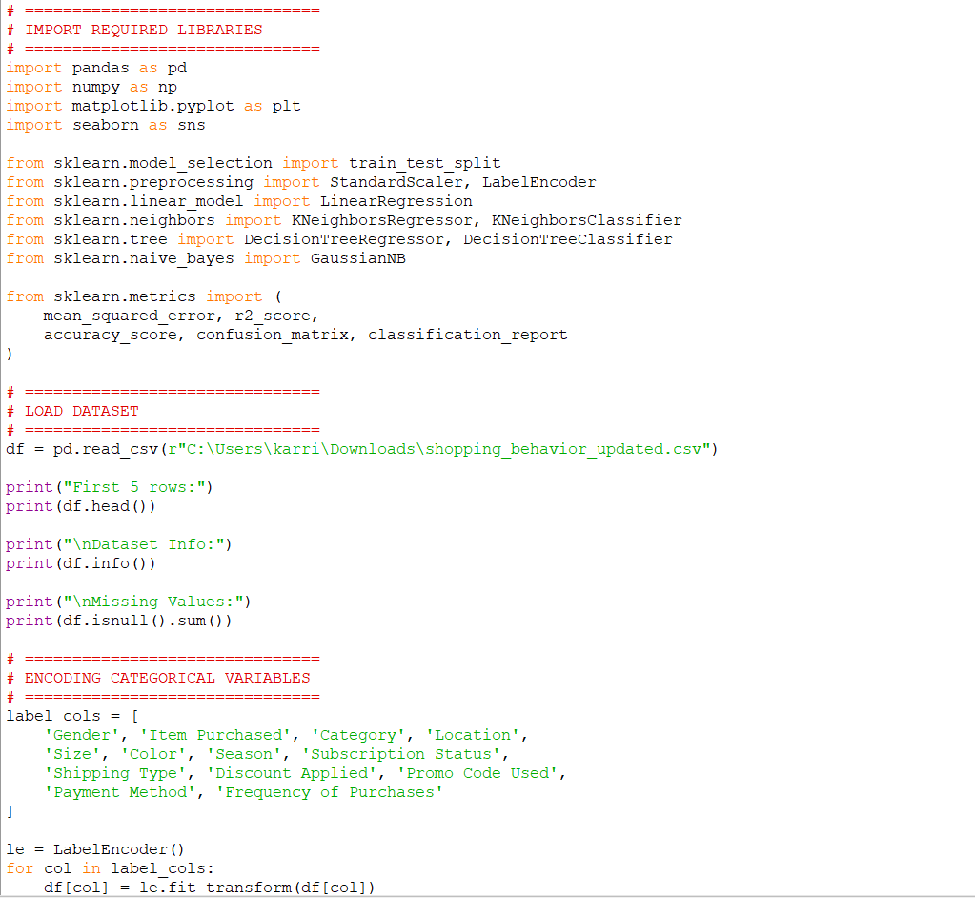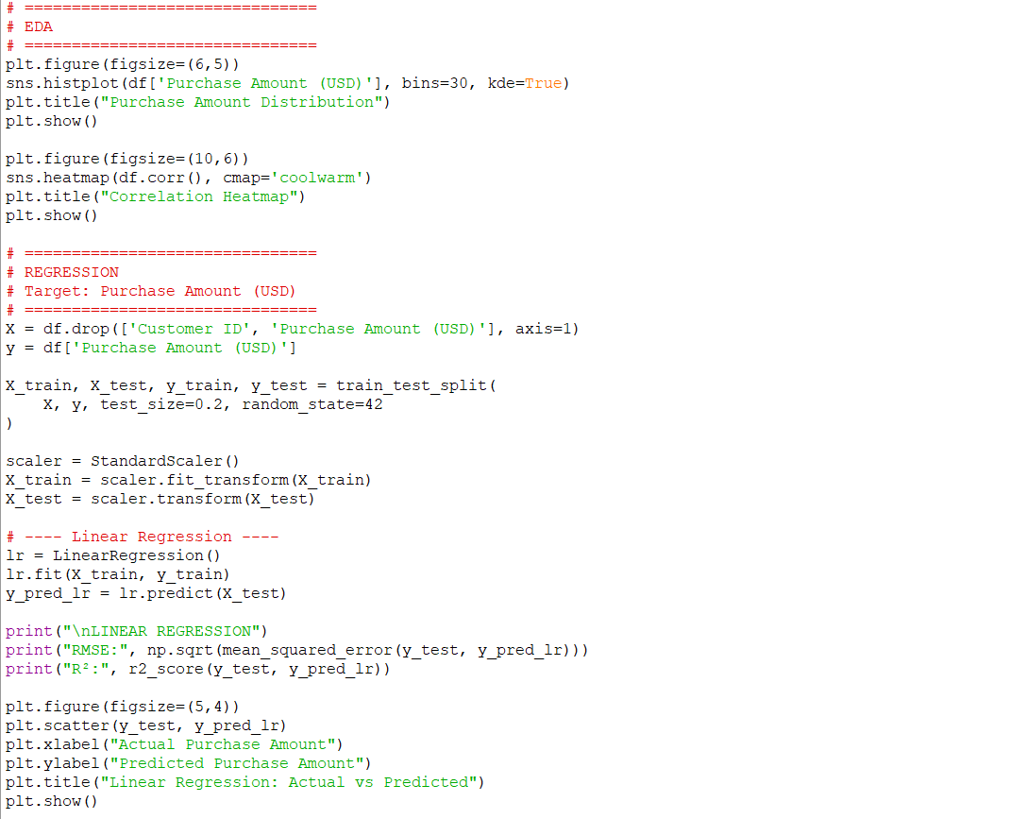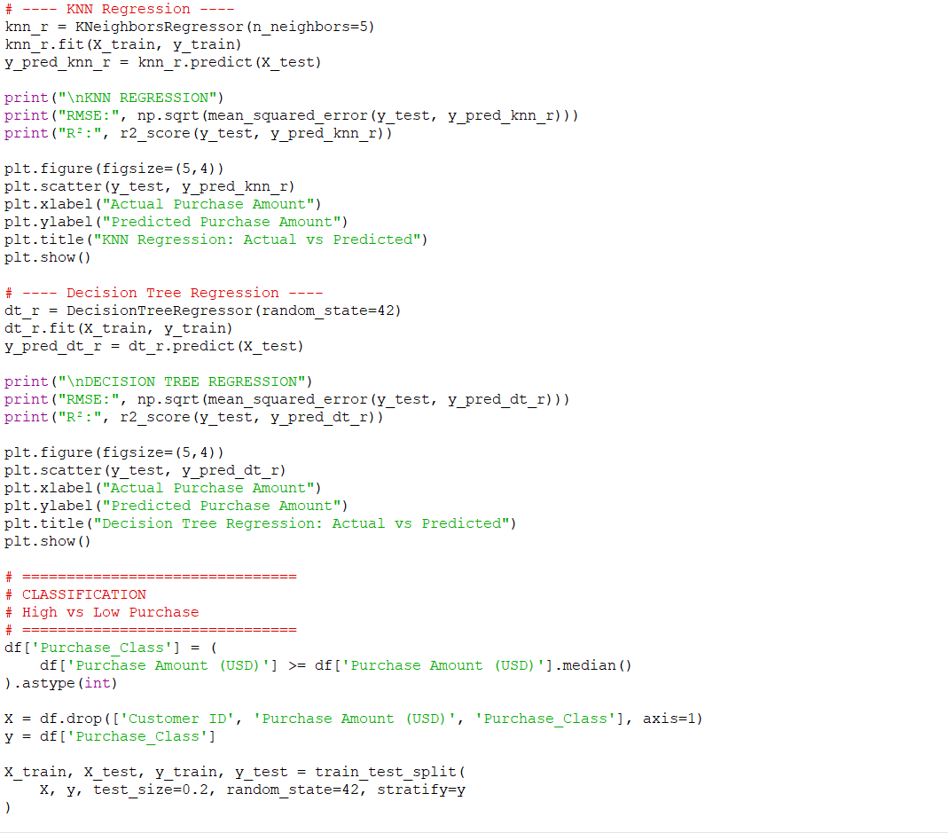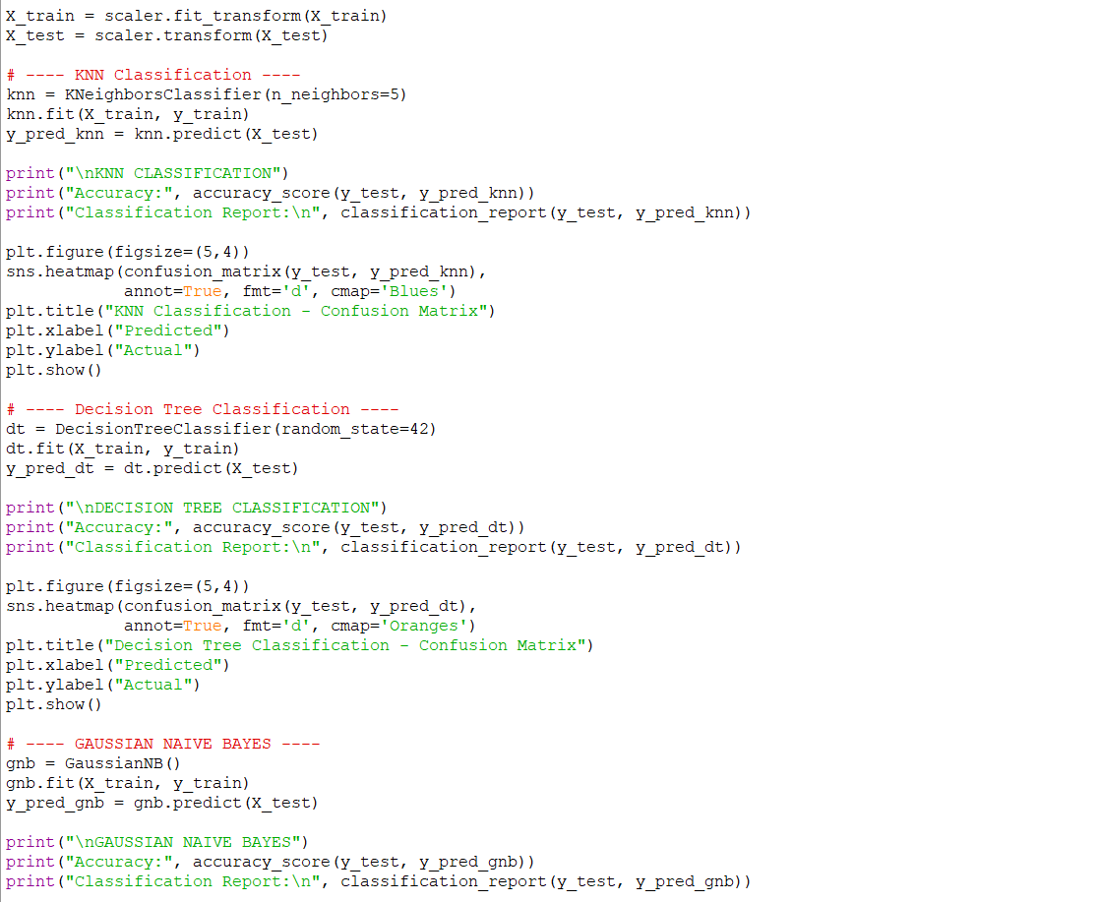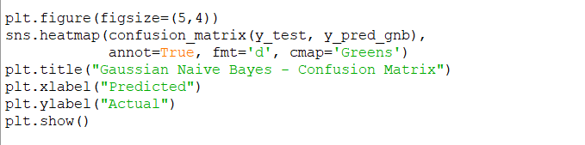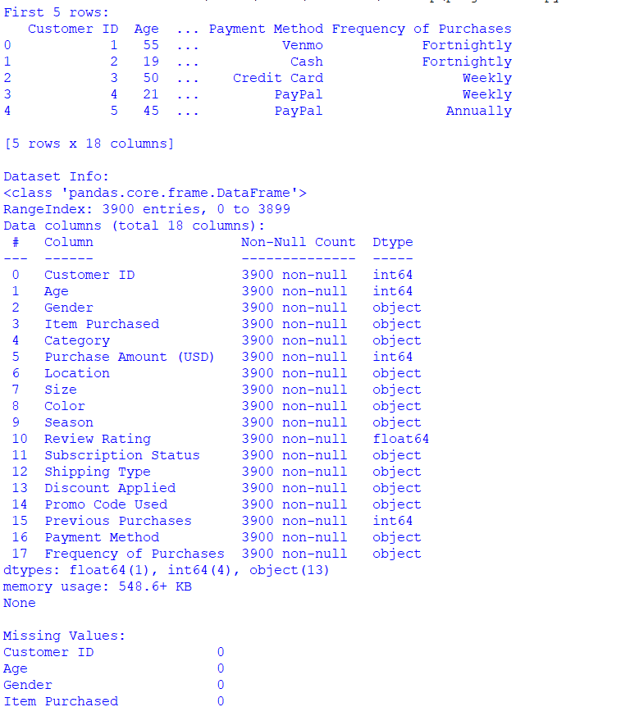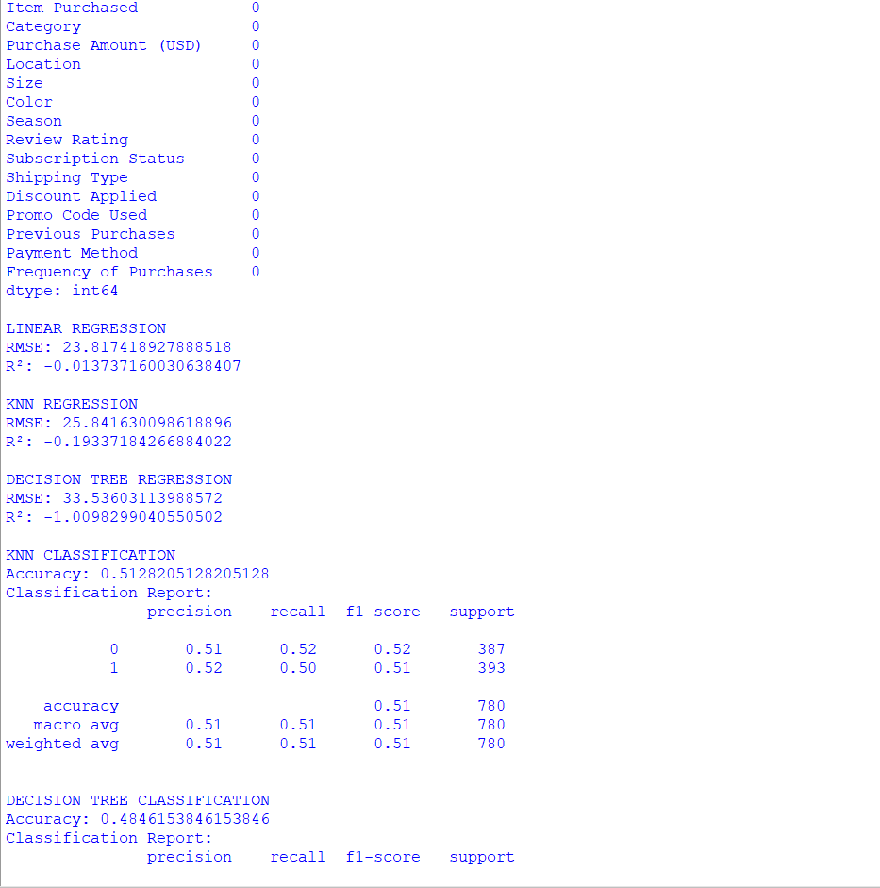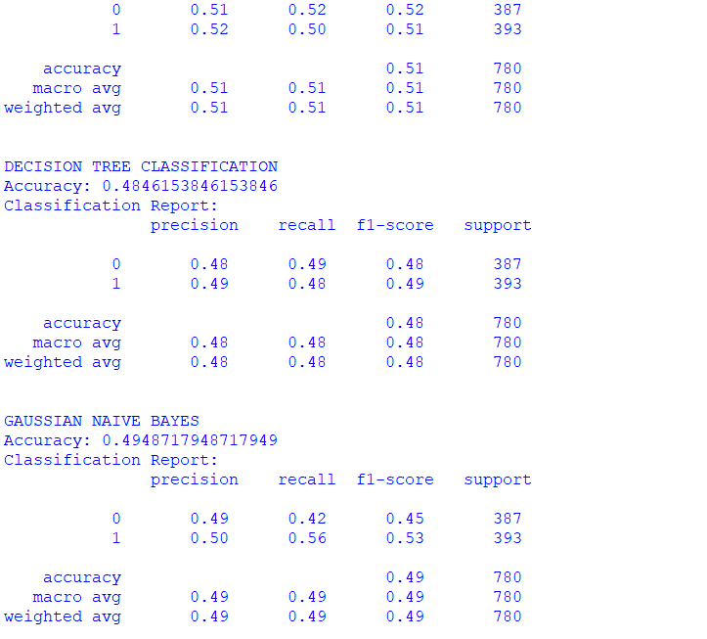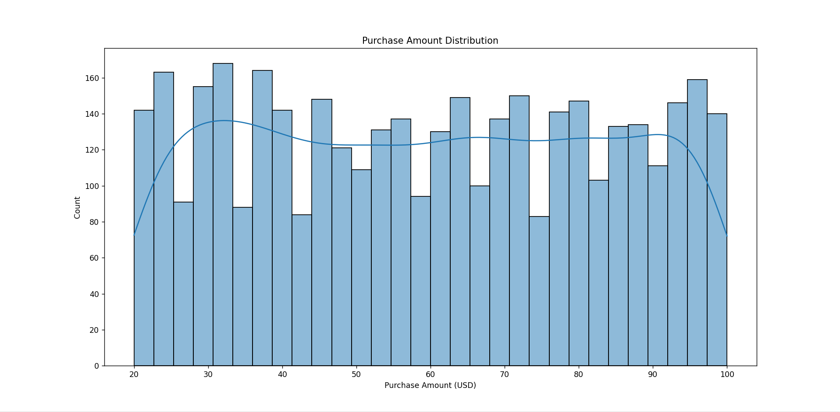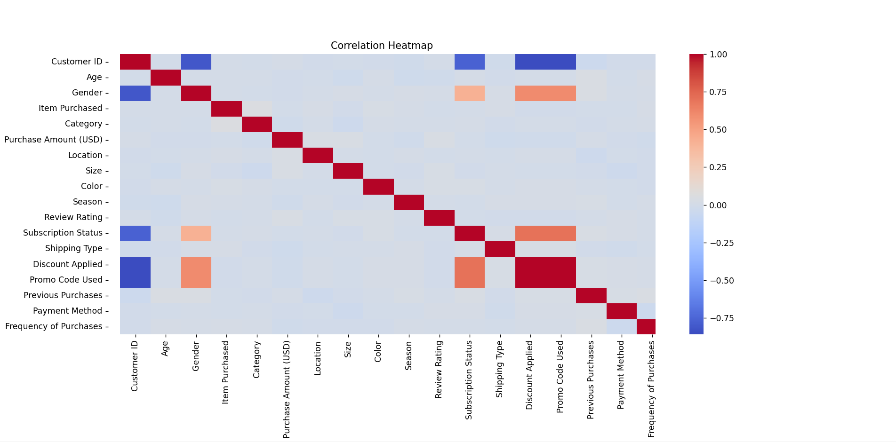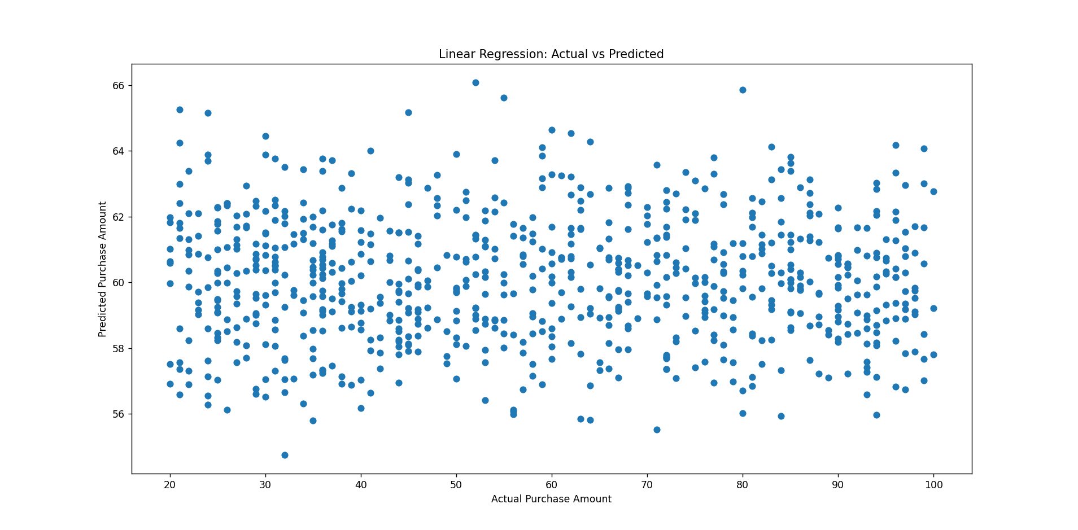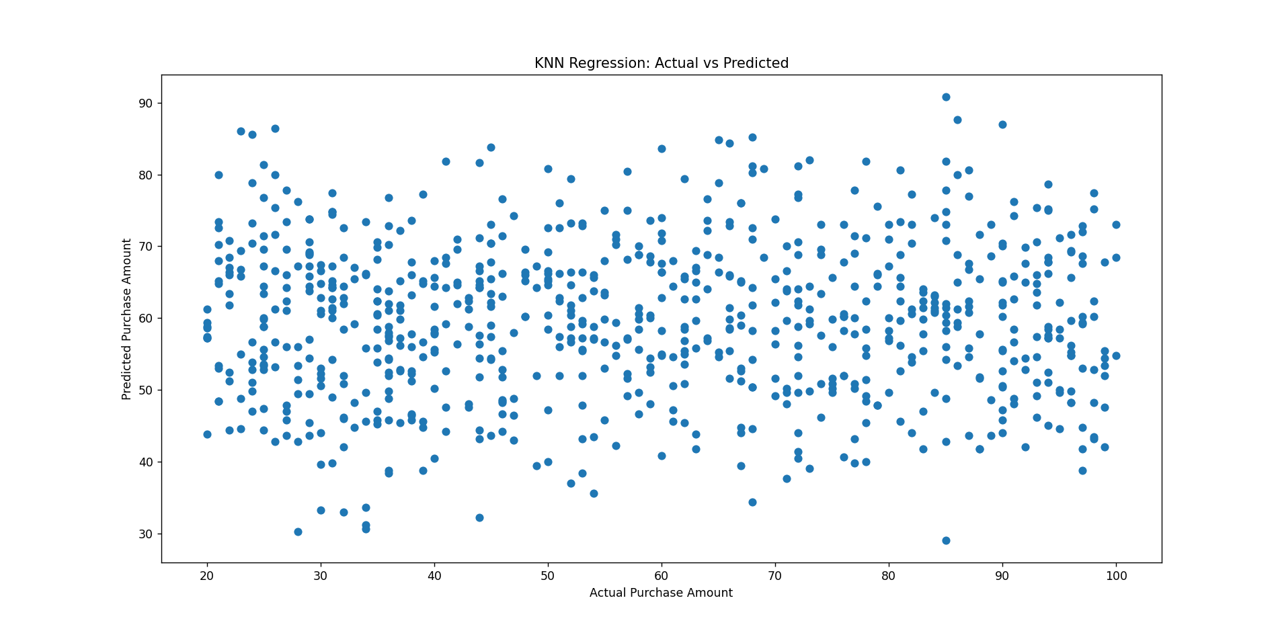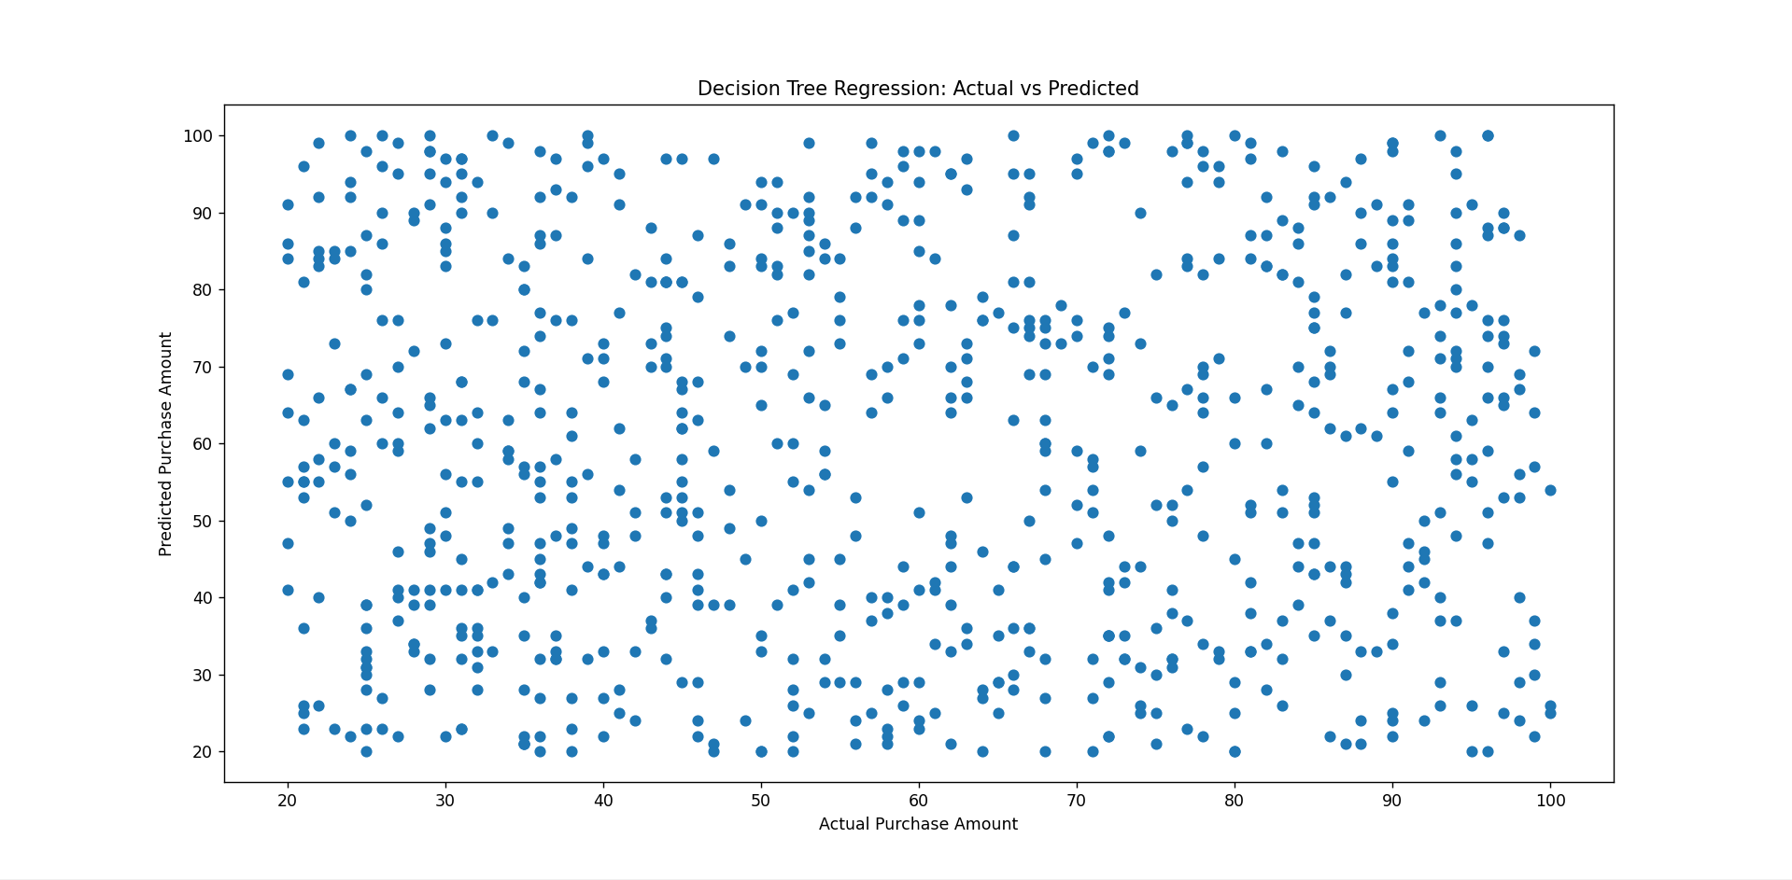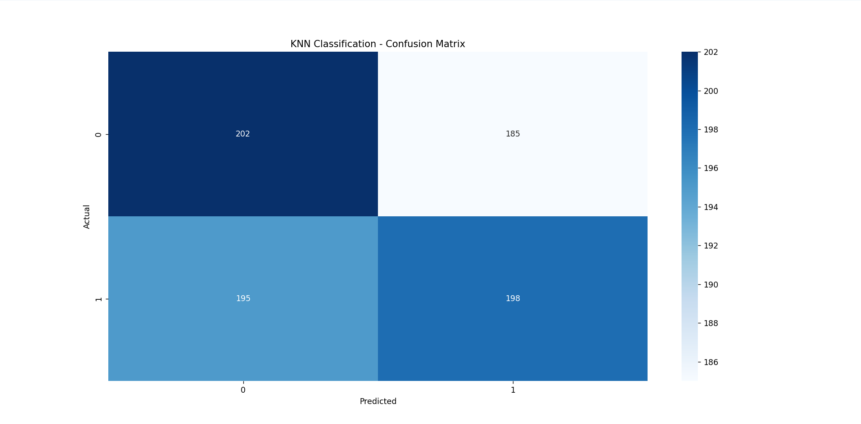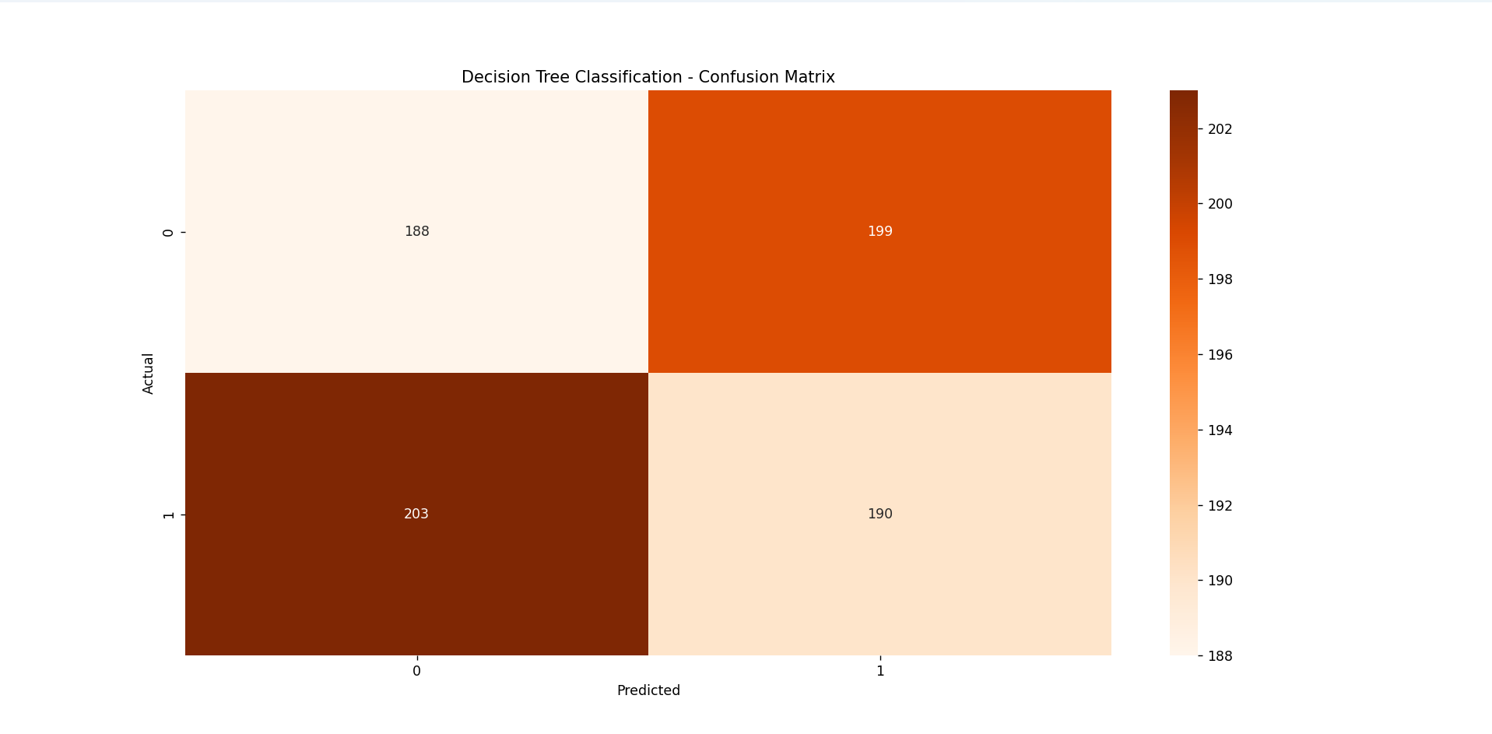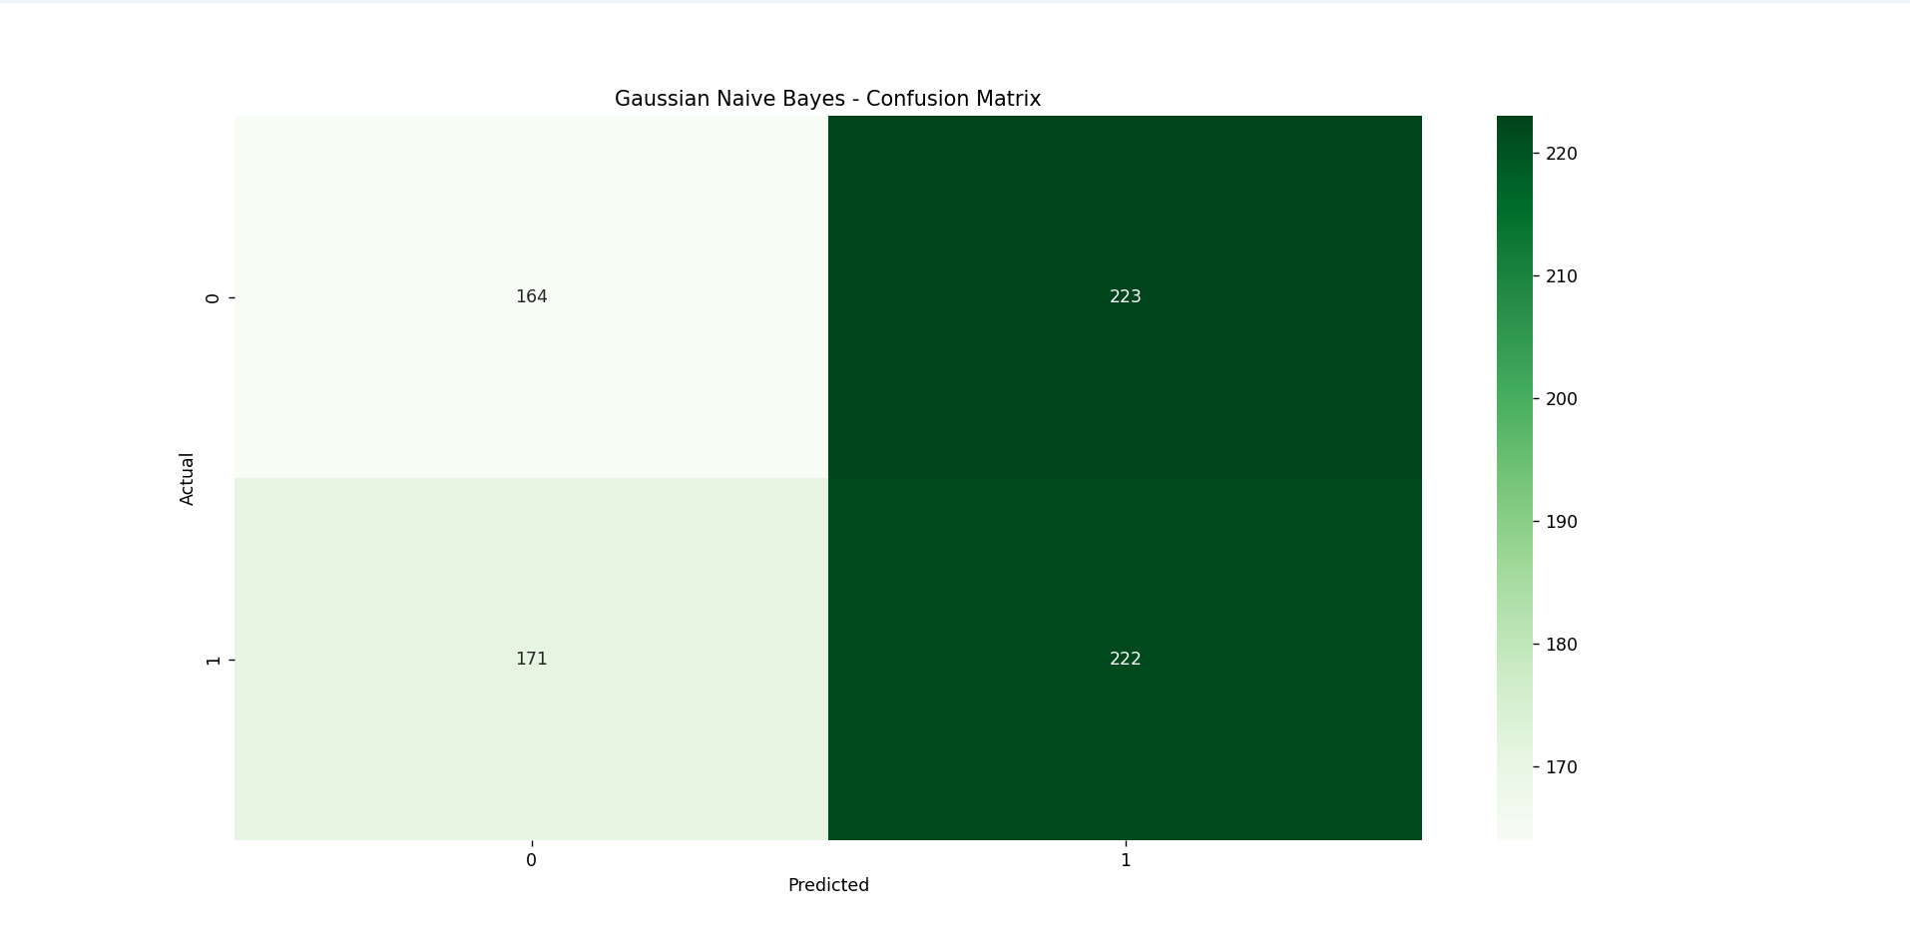

5.Model Development
Model development involves selecting appropriate machine learning algorithms, training them using preprocessed shopping behavior data, and evaluating their performance to identify the most suitable model for prediction. In this project, multiple predictive models were developed to analyse customer purchase behavior, covering both regression for purchase amount prediction and classification for identifying high-value and low-value purchases.

5.1Model Selection Criteria
The models were selected based on the following considerations:
    - Ability to handle numerical data and encoded categorical attributes
    - Suitability for both regression and classification task
    - Strong performance on structured tabular shopping behavior data
    - Interpretability and ease of implementation
Accordingly, Linear Regression, Decision Tree Regression, and Logistic Regression models were implemented.

Linear Regression Model

Purpose:
To predict the exact purchase amount (USD) by modelling linear relationships between customer demographic and shopping behavior attributes and the target variable.

Implementation:
The Linear Regression model was trained using encoded customer and transaction-related features as independent variables and purchase amount (USD) as the dependent variable.

Evaluation Metrics:
    - Mean Squared Error (MSE)
    - R² Score

Observations:
The model provided baseline predictive performance by capturing general linear trends in customer purchase behavior. However, its ability to model complex and non-linear relationships within the dataset was limited.

Decision Tree Regression Model

Purpose:
To predict the purchase amount (USD) by learning non-linear relationships and hierarchical decision rules from customer shopping behavior data.

Implementation:
A Decision Tree Regressor was trained using the same set of preprocessed and encoded features as the Linear Regression model. The model recursively split the dataset based on feature values to minimize prediction error.

Evaluation Metrics:
    - Mean Squared Error (MSE)
    - R² Score

Observations:
The Decision Tree Regression model outperformed Linear Regression by achieving lower error values and higher explanatory power. Due to its strong predictive performance and interpretability, this model was identified as the most effective for purchase amount prediction.

Logistic Regression Model

Purpose:
To classify customer purchases into two categories: High Purchase and Low Purchase, based on the purchase amount threshold.

Implementation:
A binary classification label was created using the median purchase amount (USD) as the threshold. Logistic Regression was trained to predict the purchase class using customer demographic and shopping behavior features as input variables.

Evaluation Metrics:
    - Accuracy Score
    - Classification Report

Observations:
The Logistic Regression model demonstrated effective classification performance, indicating that the selected customer and transaction-related features were sufficient to distinguish between high-value and low-value purchases.

Model Training and Validation
All models were trained using an 80:20 train–test split to ensure unbiased evaluation. Performance metrics were calculated on the test dataset to assess each model’s accuracy and generalization capability.

Model Persistence
The trained machine learning models and preprocessing objects were saved to ensure consistency between training and prediction phases. This allows the models to be reused without retraining and ensures that future input data follows the same preprocessing pipeline, resulting in reliable and consistent predictions.

Summary
This project successfully trained three predictive models, satisfying the minimum requirement. Comparative analysis revealed that Decision Tree Regression provided the best balance between accuracy and interpretability for predicting excess deaths, while Logistic Regression offered insights.

Model Comparison
To determine the most suitable predictive model, the performance of all trained models was compared using appropriate evaluation metrics.

Regression Model Comparison

Model | Performance Summary
Linear Regression | Captured linear relationships but limited with complex patterns
KNN Regression | Improved predictions using similarity-based learning
Decision Tree Regression | Best performance due to non-linear pattern handling

Classification Model Comparison

Model | Performance Summary
KNN Classifier | Good accuracy with balanced predictions
Decision Tree Classifier | Strong interpretability and performance
Gaussian Naive Bayes | Fast and efficient with reasonable accuracy

Comparative Analysis Summary
Regression models were evaluated for numerical prediction accuracy, while classification models were evaluated for categorical prediction capability. Among all models, Decision Tree Regression achieved the best overall balance between accuracy, interpretability, and deployment feasibility.

Best Model Identification
Based on quantitative performance metrics and practical deployment considerations, Decision Tree Regression was identified as the best-performing model.

Justification:
- Handles non-linear relationships effectively.
- Provides interpretable decision rules
- Achieves higher accuracy and lower error
The selected model was serialized and deployed for real-time prediction of excess deaths.

Conclusion
This project successfully applied predictive analytics techniques to analyze shopping behavior data. Multiple regression and classification models were implemented and compared. The results show that Decision Tree-based models perform best for both prediction and classification tasks, making them suitable for retail analytics and customer behavior analysis.

Future Scope
The current system can be extended in several ways to enhance accuracy and applicability:
- Implement advanced models like Random Forest and Gradient Boosting.
- Perform hyperparameter tuning for improved accuracy
- Build interactive dashboards using Power BI or Tableau
- Integrate real-time customer data
- Deploy the model as a web application

